**CIS3100**

**KARY HUANG**

**ASSIGNMENT #4**

**04/18/2016**

**INPUT**

//Kary Huang Assignment #4

#include <iostream>

#include <cmath>

#include <fstream>

#include <iomanip>

using namespace std;

float findavg(float, float, float, float); //prototype for the average function

void lettergrade(float&, char&); //prototype for the letter grade conversion function

int main()

{

ifstream a4in("C:\\Users\\kary\\Desktop\\CIS3100\\KaryHuangAssignment4\\a4in.txt");

ofstream a4out("a4out.txt");

char grade = 'A'; //initialize the variable

int student_id, grade1, grade2, grade3, grade4, count = 0;

float average;

while (a4in >> student_id) //reads the first value from the input file, then perform the following

{

a4in >> grade1 >> grade2 >> grade3 >> grade4;

a4out << "The student with ID " << student_id << " has grades " << grade1 << " " << grade2 << " " << grade3 << " " << grade4 << endl;

average = findavg(grade1, grade2, grade3, grade4); //set the result of the average function to the variable average

a4out << "The average is " << fixed << setprecision(2) << average << endl; //format the average to 2 decimal places

lettergrade(average, grade); //call the letter grade conversion function

a4out << "The grade is " << grade << endl << endl;

count++;

}

a4out << "\nThe number of students processed was " << count << "." << endl;

a4in.close();

a4out.close();

return 0;

}

float findavg(float a, float b, float c, float d) //the average function

{

return (a + b + c + d) / 4;

}

void lettergrade(float& x, char& letter) //the letter grade conversion function

{

if (x >= 90)

letter = 'A';

else if (x >= 80)

letter = 'B';

else if (x >= 70)

letter = 'C';

else if (x >= 60)

letter = 'D';

else letter = 'F';

return;

}

**INPUT VERSION 2 (just for fun)**

//Kary Huang Assignment #4 version 2 (different ways of writing the two functions)

#include <iostream>

#include <cmath>

#include <fstream>

#include <iomanip>

using namespace std;

float findavg(int, int, int, int); //prototype for the average function

char lettergrade(float, char&); //prototype for the letter grade conversion function

int main()

{

ifstream a4in("C:\\Users\\kary\\Desktop\\CIS3100\\KaryHuangAssignment4\\a4in.txt");

ofstream a4out2("a4out2.txt");

char grade = 'A'; //initialize the variable

int student_id, grade1, grade2, grade3, grade4, count = 0;

float average;

while (a4in >> student_id) //reads the first value from the input file, then perform the following

{

a4in >> grade1 >> grade2 >> grade3 >> grade4;

a4out2 << "The student with ID " << student_id << " has grades " << grade1 << " " << grade2 << " " << grade3 << " " << grade4 << endl;

average = findavg(grade1, grade2, grade3, grade4); //set the result of the average function to the variable average

a4out2 << "The average is " << fixed << setprecision(2) << average << endl; //format the average to 2 decimal places

lettergrade(average, grade); //call the letter grade conversion function

a4out2 << "The grade is " << grade << endl << endl;

count++;

}

a4out2 << "\nThe number of students processed was " << count << "." << endl;

a4in.close();

a4out2.close();

return 0;

}

float findavg(int a, int b, int c, int d) //the average function

{

return (a + b + c + d) / 4.0;

}

char lettergrade(float x, char& letter) //the letter grade conversion function

{

if (x >= 90)

letter = 'A';

else if (x >= 80)

letter = 'B';

else if (x >= 70)

letter = 'C';

else if (x >= 60)

letter = 'D';

else letter = 'F';

return letter;

}

**OUTPUT**

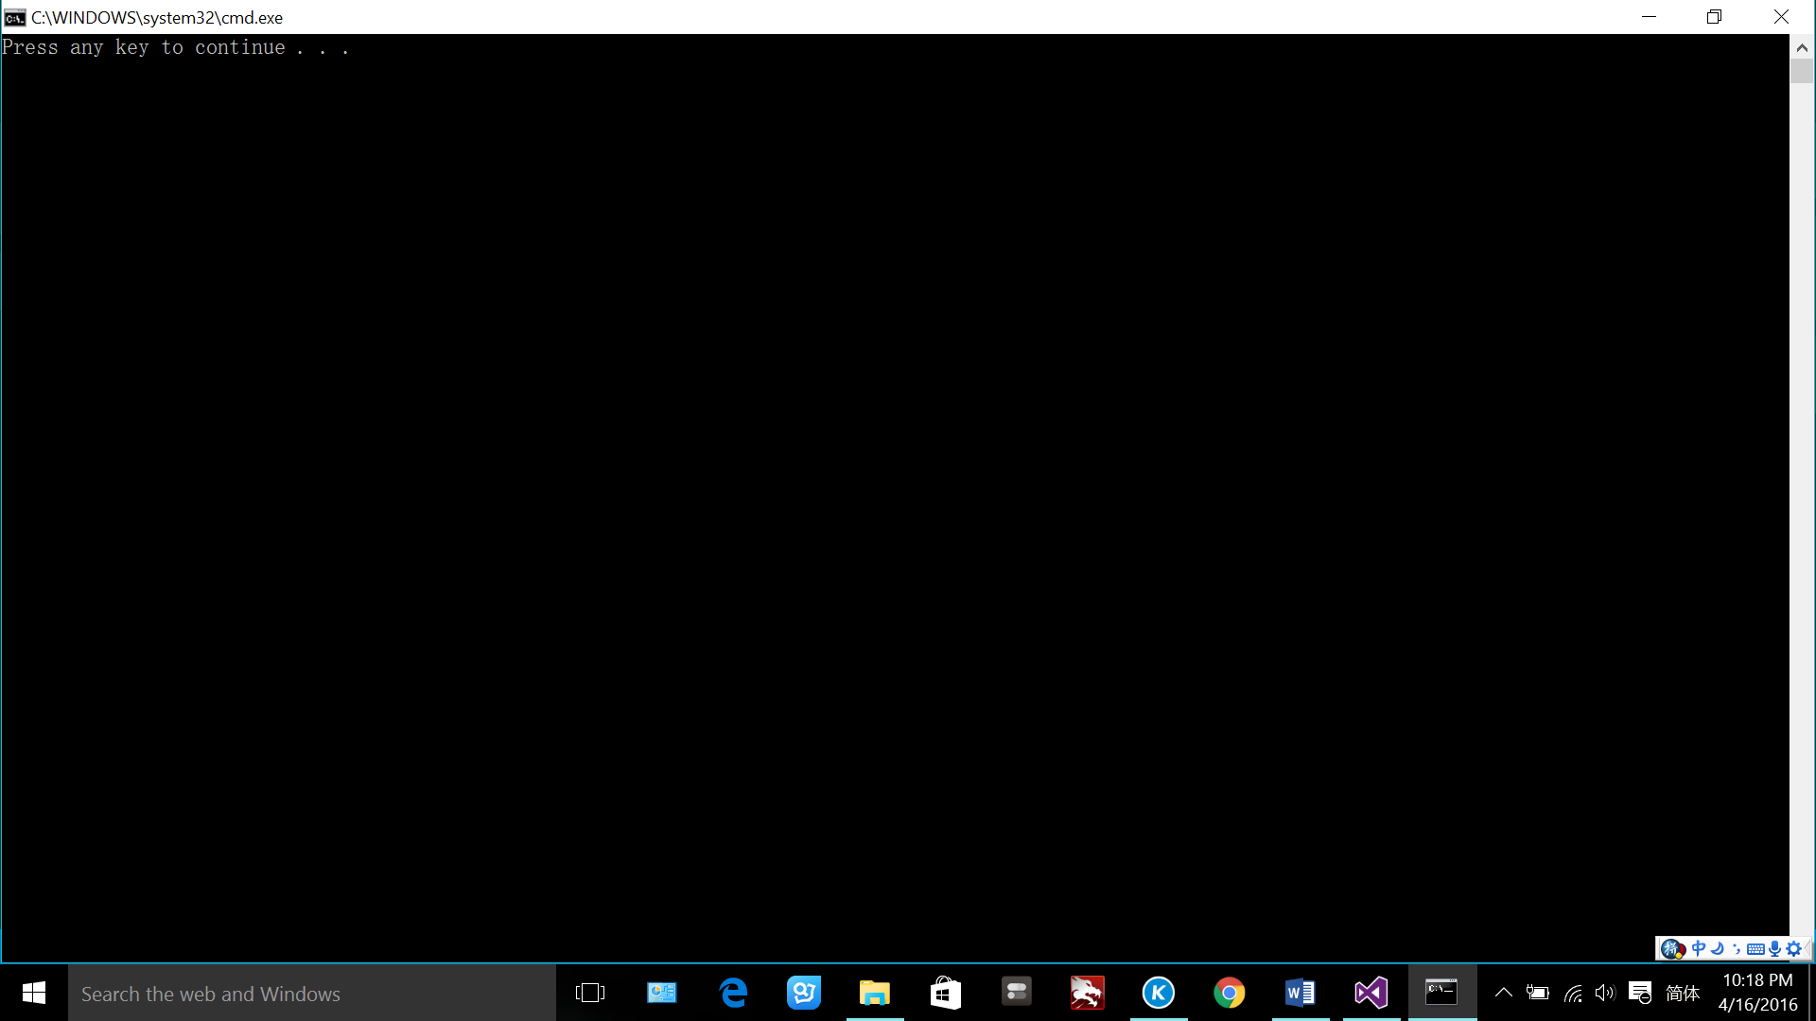

**a4in.txt**

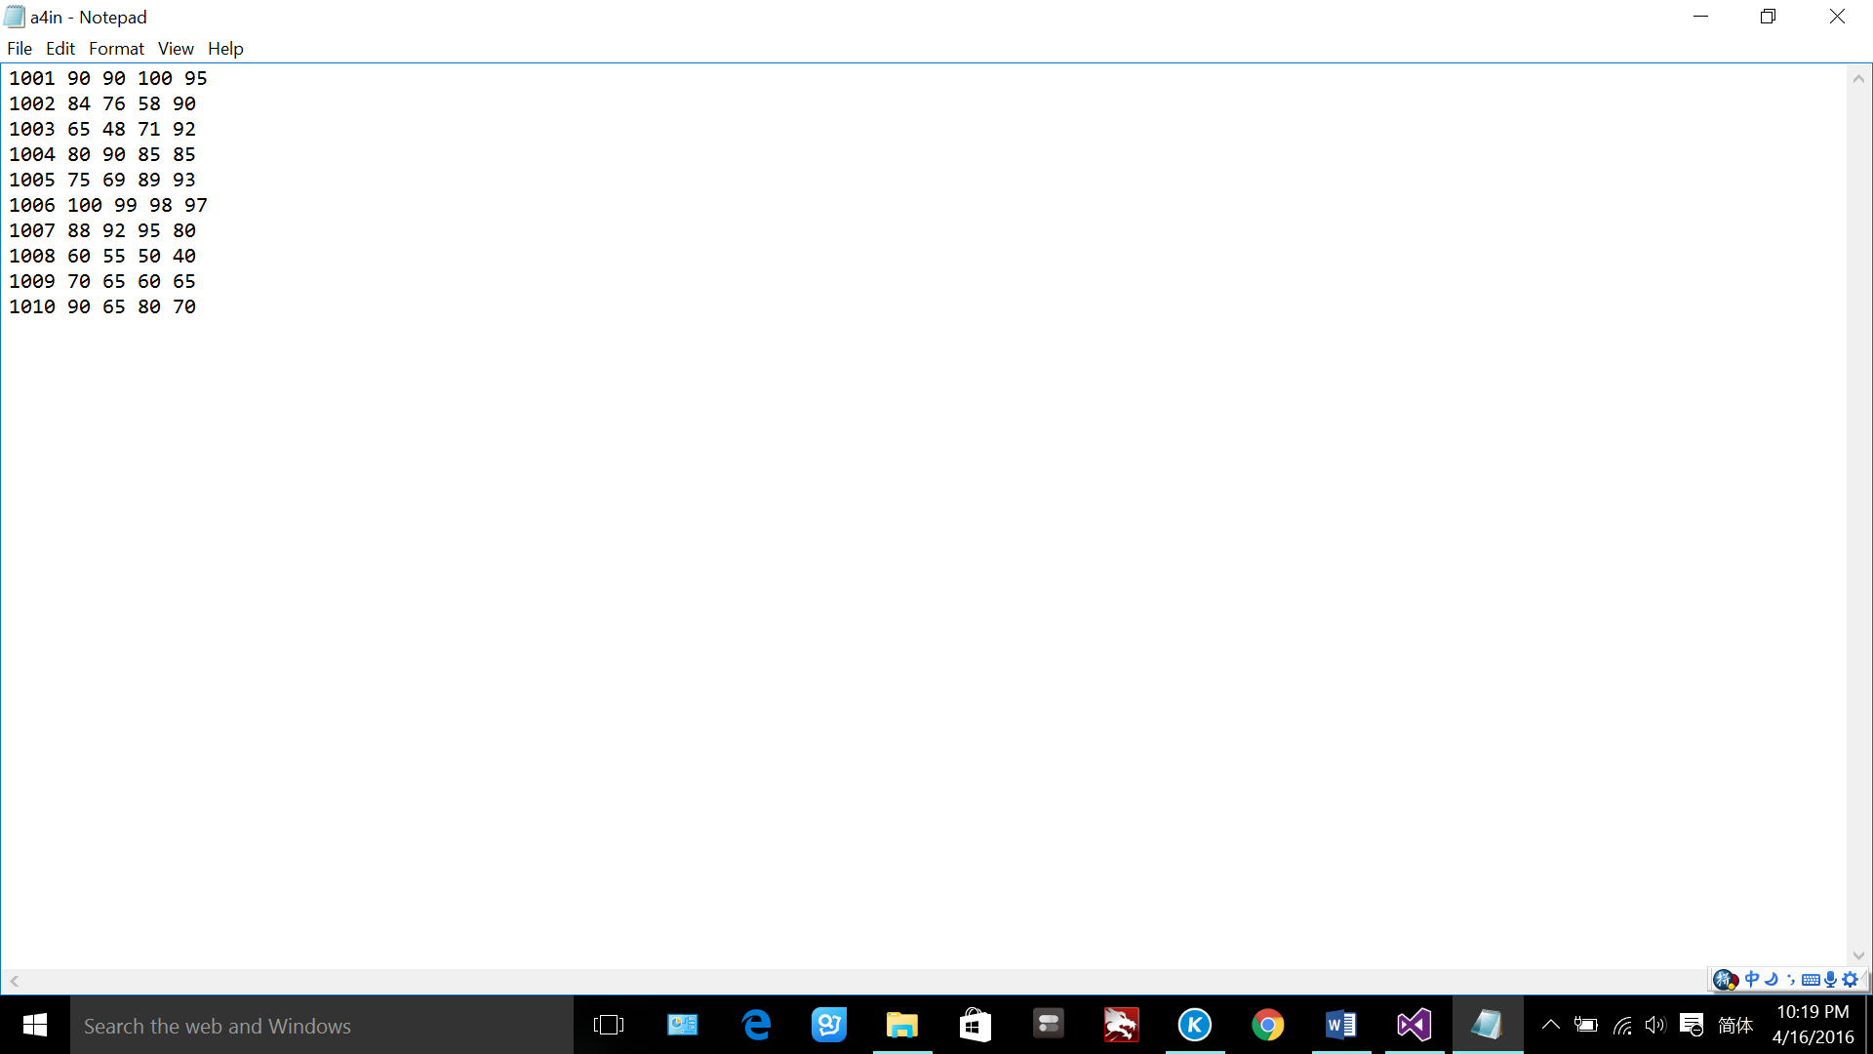

**a4out.txt**

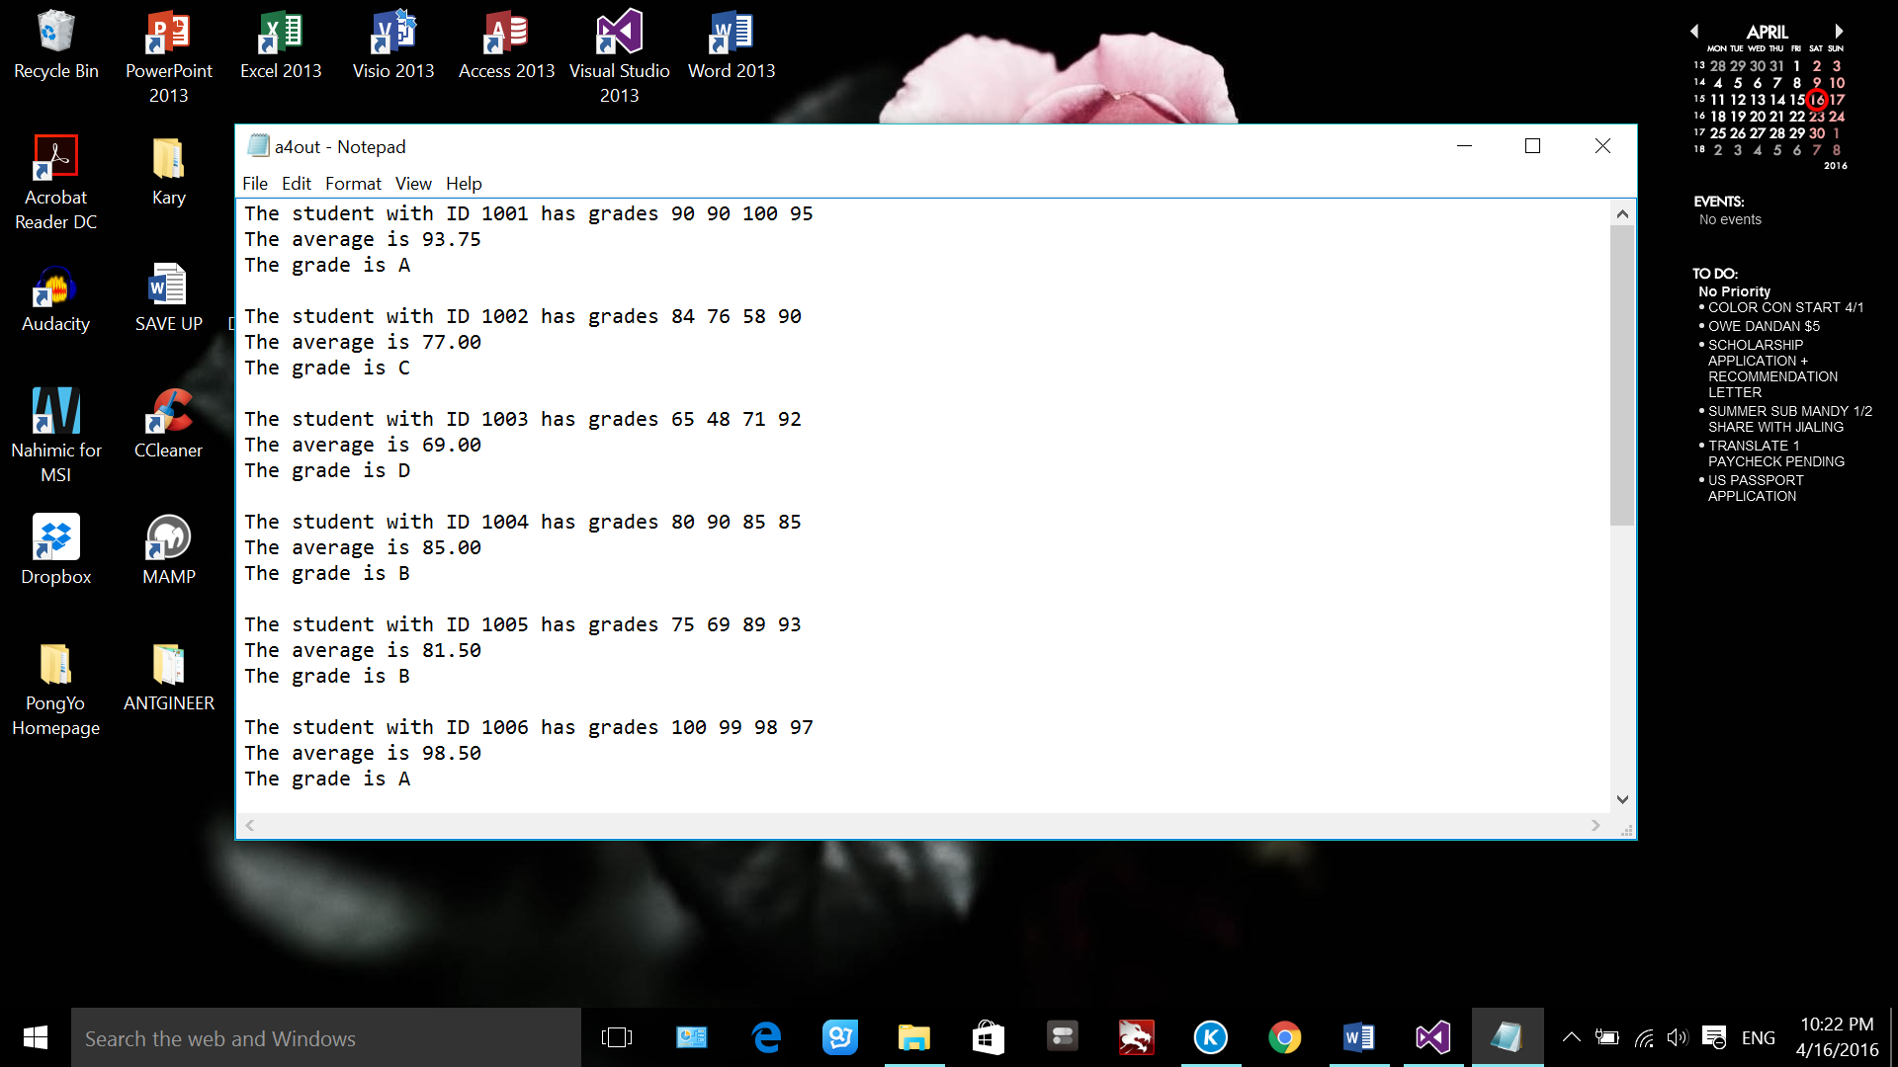 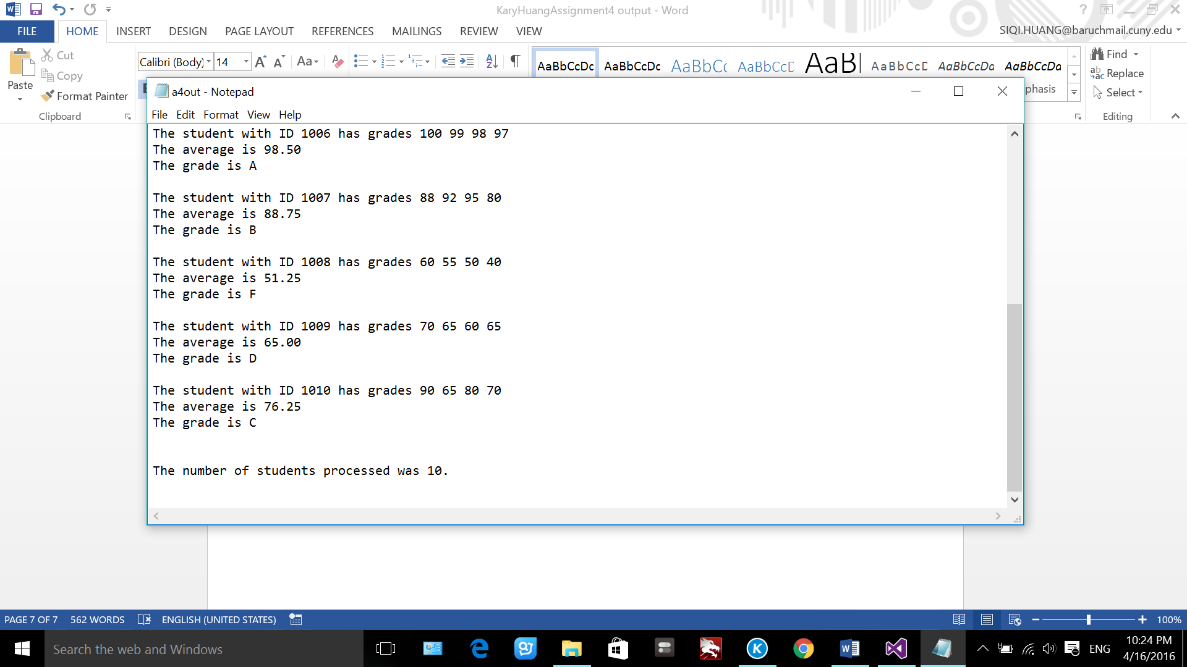

**a4out2.txt**

